Explorer Monument

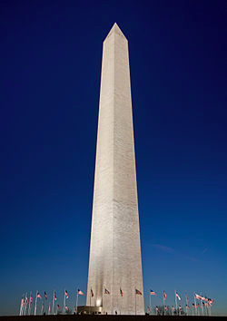A **monument** is a type of structure created to commemorate a person or important event, which has become important to a social group as a part of their remembrance of historic times or cultural heritage.

The **Washington Monument**is an [obelisk](http://en.wikipedia.org/wiki/Obelisk) on the [National Mall](http://en.wikipedia.org/wiki/National_Mall) in [Washington, D.C.](http://en.wikipedia.org/wiki/Washington,_D.C.), built to commemorate [George Washington](http://en.wikipedia.org/wiki/George_Washington), commander-in-chief of the [Continental Army](http://en.wikipedia.org/wiki/Continental_Army) and the first American

President.

Directions:

After conducting research on your chosen explorer, create a monument for your explorer using heavy cardstock. You will make a triorama to hold your monument. Include at least two paragraphs on your triorama highlighting information/answers/research from your target questions. Be sure to use opening and closing sentences on each paragraph. Use the template provided to create your triorama. Below are some examples of trioramas.

